W228A/1204C, W228B/1204C



DUBLIN INSTITUTE OF TECHNOLOGY
_____________

DT228A/1 MSc in Computing
DT228B/1 MSc in Computing
______________

WINTER EXAMINATIONS 2015/2016
______________

Probability and Statistical Inference [Math9100]

Ms. deirdre Lawless
Dr. Deirdre Lillis
Mr. Conor sayles

Monday 18th January 9.30 a.m. – 11.30 a.m.

Two Hours

SOLUTIONS

Answer question one and one other question.

All questions carry equal marks.

1. |  | A researcher in nutrition is currently researching red meat purchases in Ireland. They have developed a theory as part of their research that there is a correlation between average number of hrs of TV watched per week and the average number of purchases of red meat per week. Further they theorize that there is a difference in the number of purchases based on gender. Traditionally a 5% cut-off level of statistical significance is used within the research domain. A dataset comprising 386 records has been collected by conducting a phone survey.
  Variables of concern in the dataset
  Name | Label | Values | Type
  Purchases | Number of red meat purchases last week |  | Scale
  Gender | Gender | 1=Male, 2=Female | Categorical
  TVHrs | Number of Hrs of TV watched last week |  | Scale
  ZPurchases | ZScore Number of purchases |  | Scale
  ZTVHrs | ZScore Number of Hrs TV Watched |  | Scale
1. | (a) | Explain the steps that the researcher should take in developing and testing their hypotheses.  In your answer you should derive relevant hypotheses, discuss the concepts of statistical significance and the role probability plays in this, statistical power, Type I and Type II errors.  (15 marks)
Marking:
3 marks discussion of steps of hypothesis testing:
2 marks Correct hypotheses pairs (two required)
2 x 3 marks Explanation of statistical significance and relationship with probability and Explanation of statistical power;
2 x 2 marks Type I error; Explanation of Type II error with linking statistical significance, statistical power
Expectations of answer:
Hypothesis testing steps: Derive null and alternate hypotheses; identify type of test needed based on hypothesis; decide on cut-off and critical value; conduct the test to compute test statistic; interpret statistical significance and test statistic; conclude on whether to accept/reject null hypothesis.
H0: There is no relationship between TVhrs and purchases/Ha: there is a relationship; H0: there is no difference in the relationship between TVhrs and purchases for different genders/HA: there is a difference
Sig:; means the statistic is reliable to cut-off level can conclude level of evidence to reject null hypothesis to this level e.g. 5%=p value 0.05 ; p value is the probability value is the probability of an outcome given the hypothesis
Power: probability of correctly rejecting a false null hypothesis; sample size is key possible in small sample size that even a fairly large population difference would be difficult to detect and no strong conclusions can be drawn about the population; expect consideration of dataset size provided
Type I: incorrect rejection of correct null hypothesis
Type II: failure to reject null hypothesis

1. | (b) | Missing data, Outliers, Skewness and Kurtosis are issues of concern in statistical analysis.  Discuss what is involved in screening your data and the options v available to address these issues, explaining the consequences of not assessing the impact prior to conducting your statistical analysis.  Illustrate your answer with reference to the statistics and graphs provided in Appendix A. From your answer you should conclude whether you should use parametric or non-parametric tests are suitable for use in this research.  (25 marks)
Marking:
2 x 5 marks Missing data and Outliers (3 marks discussion, 2 marks application to information provided)
2 x 4 marks (2 marks discussion, 2 marks application) Skewness, Kurtosis
5 marks Consequences – focus on implications for normality and thus significance, power, type I and II
2 marks Decision on parametric or non-parametric with justification
Expectations of answer:
Missing Data: Need to identify reason for missing; Need to care because source of bias, could reduce statistical significance and power, increase risk of type I and type II; Should address MCAR, MAR, MNAR, distinguish between then and discuss detection: MCAR Little’s test, patterns to infer MAR, if cannot find reason from pattern then MNAR; Options – delete, impute, repeat analysis with and without the data; Expect discussion of info provided: numbers missing, Little’s test.
Outliers: Cases with values very different to majority of data – source of bias; inspect histogram and box plots, normal quantile plot and look at frequency tables; Expect discussion of box plots and zscore frequency tables could also consider histograms; 95% to fall within +/-1.96 none greater than +/-3.29; Options delete, continue, repeat analysis twice
Skewness: measure of the asymmetry of the probability distribution – source of bias; discuss skewness statistic; acceptable range +/-2; could transform
Kurtosis: measure of whether the data are peaked or flat relative to a normal distribution – source of bias; should discuss kurtosis statistic; acceptable range +/-2; could transform
Consequences: normality: outliers, missing data all impact on normality; should discuss normality test statistics; should address statistical significance, power, type I and type II

1. | (c) | Based on your answer to part (a) and (b), using the results of the relevant test provided in Appendix A, interpret the correlation between number of hrs of TV watched and the number of red meat purchases and explain what can be concluded about this relationship.  (10 marks)
2 marks selection of correct test based on interpretation provided in part (b)
2 x 3 marks correct interpretation of correlation coefficient and statistical significance
2 marks conclusion about the relationship: strong correlation that is statistically significant but cannot conclude that one variable is causing change in the other

2. | The researcher decided to explore the relationship between the number of red meat purchases made, the average number of hrs of TV watched and gender.
 | (a) | The researcher first created a simple linear regression model including standardised score for the average number of hrs of TV as the predictor variable for the standardised score for the number of red meat purchases made.  Explain what linear regression will allow the researcher to do and what in this context prediction means. Illustrate your answer by using the additional statistics provided in Appendix B to state the regression equation, interpret the model and assess the fit and usefulness of the model considering the coefficients, R² , Adjusted R²and F statistic.  (20 marks)
Marking:
2 marks explanation of what regression will allow researcher to do
2 marks explanation of what prediction is in this context
3 x 4 marks explanation and assessment of the coefficients, R2 and F statistic
4 marks statement of equation and correct interpretation of the model

Expectations of answer:
Regression will allow researcher to explore how well a set of variables is able to predict an outcome variable; which variable in a set is the best predictor; whether a variable is still able to predict an outcome when controlling for a particular variables
Prediction: looking at is the variance in the outcome variable and how much of the variance could be considered to be explained by the predictor variables
Regression equation zpurchases= -0.30 + 0.858* ztvhrs
Coefficients: Measure the strength and direction of relationships between independent variables and the dependent variance – need to consider the significance of these
R2: the proportion of variance in the outcome (dependent) variable which can be explained by the predictor (independent) variables. An R2 of 1 means the independent variable explains 100% of the variance in the dependent variable. Conversely 0 means it explains none.
F statistic: Whether the model as a whole predicts the dependent variable
Its statistical significance is the significance of the model
Fit and usefulness: assessment of R2 and F plus coefficients: model is statistically significant, TV hrs is a significant predictor, explains 74.8% of the variance
Interpretation: should consider increase in one unit of Ztvhrs and its impact on purchases

2. | (b) | Differences in the number of purchases based on gender have been found. Suppose the researcher has extended the model to include gender by incorporating a dummy variable dummyGender which has a value 0 for male and 1 for female.  Explain clearly why a dummy variable is needed before using the information provided in Appendix B to state the regression equation, interpret this second model for both males and females and assess its fit and compare it to the model created in part (a).  (18 marks)
Marking:
3 marks explanation of dummy variable
3 marks correct assessment of model fit and usefulness of model, explains 74.8%, model is significant
3 marks comparison with other model including any change in coefficient for TV hrs watched – no overall change in model but change in TV hrs coefficient which remains statistically significant
4 marks correct interpretation of coefficients and significance, gender not significant, coefficient of TV hrs changed
5 marks correct regression equation and application to male and female
Expectations of answer:
Dummy variable: interested in effect of characteristic, if include 1 and 2 will act as multiplier, 0 and 1 can see effect and its absence
Assessment of fit and usefulness: Adjusted R2 and Fstat
Regression equation: zpurchases = -0.42 + 0.863 * zTVhrs + 0.32 * dummygender
Should look at model for male and female 0.443 MALE, .763 FEMALE

2. | (c) | Three major concerns for multiple linear regression are multicollinearity, normality of the residuals and outliers.  Explain these concerns and why they are important. Illustrate your answer with reference to the model created for part (b) using the information provided in Appendix B.  (12 marks)
Marking:
3x 4 marks (2 marks explanation and importance, 2 marks illustration)
Expectations of answer:
Multicollinearity: Occurs when two or more independent variables contain strongly redundant information; If variables are collinear then it means there is not enough distinct information in these variables for MLR to operate – they are essentially measuring the same thing; Examining a correlation matrix that compares your independent variables with each other; coefficient above 0.8 suggests collinearity might be present Consider: VIF = variance inflation factors - Tells you what the standard error would be if the variable was uncorrelated with others; Values of VIF that exceed 2.5 should be cause for concern; Tolerance – should be concerned if it is lower than 0.4. If it is a concern you need to analyse your variables in separate regression equations and then examine how they operate. Correlation strength is an issue but VIF and tolerance not for data provided.
Normality of residuals: Should follow a normal distribution with a mean of 0; Since the residuals measure where the points fall in relation to the regression line, a normal distribution of residuals indicates that the same number of points fall above and below the line; Look at histogram and residual statistics. Appears to be a problem – need to consider outliers.
Outliers: MLR can be greatly influenced by outliers - They ‘pull’ the equation away from the general pattern
Sometimes it is reasonable to delete the outliers; Sometimes you need to retain the outlier – it may be your most important observation; Sometimes it is a good idea to do your analysis twice – once with and once without the outlier to see how much influence it is having on the model
Look at the Minimum and Maximum values next to Std. Residual (Standardised Residual) subheading.
We would expect 95% to fall within +1.96 and -1.96 if our p value cut-off is 0.05 (5%).
If the minimum value is equal or below -3.29, or the maximum value is equal or above 3.29 then you have outliers. Appears to be an issue for this data
Cook’s distance: Measures the effect of deleting a case; Look at Cook’s distance for values greater than one – no major impact by deleting

3. |  | Explain clearly the objectives of exploratory factor analysis and principal component analysis. Explain the difference between them and when you would use each technique. (10 marks)
Marking:
2 x 3 marks objectives of EFA and PCA; 2 marks explanation of difference; 2 marks explanation of use
Expectations of answer:
Objectives: Reduce the number of variables; Evaluates the construct validity of a scale, test, or instrument; Development of parsimonious (simple) analysis and interpretation; Addresses multicollinearity (two or more variables that are correlated)
Differences/Use EFA and PCA: EFA Determine the nature of and the number of latent variables that account for observed variation and covariation among set of observed indicators; Used to develop theoretical constructs; Used to prove/disprove proposed theories; only shared variance is used; PCA Reduce multiple observed variables into fewer components that summarize their variance; All of the variance in the variables is used

3. |  | The researcher in the case study provided collected additional variables about the type of TV watched. Each variable represents the number of hrs on average spent watching that type of TV weekly.  Discuss the suitability of the dataset and the reliability of the scale for use in exploratory factor analysis. Illustrate your answer with reference to the additional statistics and graphs provided in Appendix C. (15 marks)
  Variable Name | Label
  TVdrama | Watch TV drama
  TVgardening | Watch TV gardening
  TVcook | Watch TV cooking
  TVcomedy | Watch TV comedy
  TVdocumentary | Watch TV documentaries
  TVfilms | Watch TV films
  TVdrama | Watch TV drama
  TVnews | Watch TV news
  TVcuraff | Watch TV current affairs
Marking:
3 marks Sample size and sample to variable ratio (1 for explanation, 2 for interpretation); 5 marks Factorability of the correlation matrix (2 for explanation, 3 for interpretation); 4 marks Kaiser-Meyer-Olkin (KMO) /Bartlett's (2 for explanation, 2 for interpretation); 3 marks Reliability – Cronbach’s alpha (1 for explanation, 2 for interpretation)
Expectations of answer:
Sample size, sample to variable: generally at least 300 cases needed; N:p ratio where N = no of cases, p=no of variables rule of thumb 10:1. Not an issue here. Alternate rules may be accepted; no issues here
Factorability of the matrix: looking at relationships between individual variable; correlation coefficients >0.30 indicates that the factors account for approximately 30% relationship within the data, or in a practical sense, it would indicate that a third of the variables share too much variance – good indicator for EFA. If no correlations need to rethink use of EFA. Here have correlations between documentaries and news, news and current affairs, documentaries and current affairs, comedy and film, gardening and cooking.
KMO proportion of variance in variables that might be caused by an underlying factor. High values close to 1 suggest that FA useful, anything less than 0.5 FA won’t be useful. Bartlett tests that variables are correlated. Looking for a statistically significant p value which suggests that they are related and a FA would be useful. No issues for this data.
Reliability accuracy and precision of a measurement procedure; Cronbach’s alpha – index of reliability associated with the variation accounted for by the true score of the "underlying construct"; Acceptable level depend on the purpose of the instrument. Acceptable 0.60. For this data it is 0.58 – approaching reliability. No significant improvement by deleting items.

3. |  | Suppose he researcher conducted an Exploratory Factor Analysis using Principal Axis Factoring as the extraction method and Varimax as the rotation.  Explain how factor analysis works focusing on factor extraction, loadings, rotation and variance explained. Illustrate your answer by interpreting the output of the factor analysis conducted for this research using the information provided in Appendix C.  (25 marks)
Marking:
4 marks extraction (2 for meaning, 2 for application)
4 marks rotation (2 for meaning, 2 for application)
4 marks communalities (2 for meaning, 2 for application)
4 marks variance (2 for meaning, 2 for application)
6 marks loadings (2 for meaning, 2 for pre-rotation and 2 for post-rotation)
3 marks correct identification of factors
Expectations of answer:
Extraction: aim is reduce a large number of items into factors. Need to decide how many factors to retain. Criteria for extraction: Kaiser’s criteria (eigenvalue > 1 rule), the Scree test, the cumulative percent of variance extracted.
Rotation: Unrotated results from a factor analysis are not easy to interpret, although the plot helps. Rotation helps clarify and simplify the results of a factor analysis. Conceptually, the axes are being rotated so that the clusters of items fall as closely as possible to them. Making the factor loading pattern much clearer as one of the two pairs of coordinates for each item tends to be close to 0.00
Variance: Looking at total variance explained for factors with eigenvalues > 1; factor 1 explains 25.98% of total variance; factor 2 17.45 and 3 15.2; After rotation factor 1 14.3, 2 11.1, 3 10.9; Rotation equalises the importance of the factors.
Communalities: proportion of the common variance within a variable; looking at extraction column – all above .3 except TV drama – could consider taking this out of the EFA and exploring the impact.
Should look at factor loadings before rotation and after to see difference
Should draw conclusions about the number of factors and variance explained - three factors extracted : TV for information, TV for entertainment, TV for hobbies and interest (namings can vary)

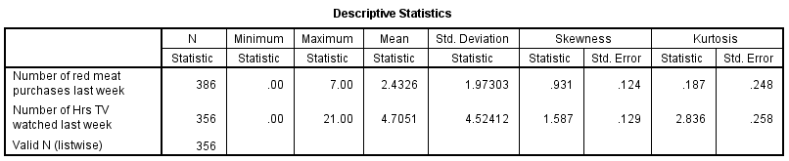  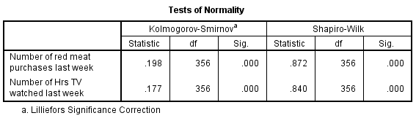 |  | 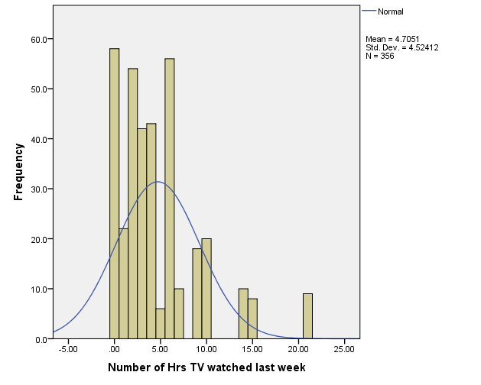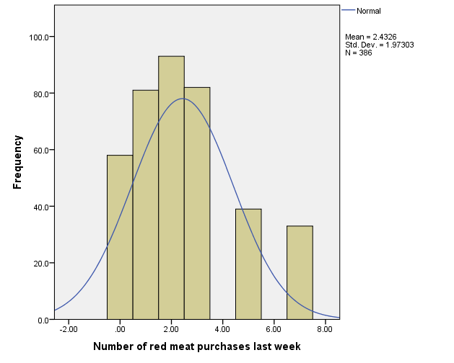
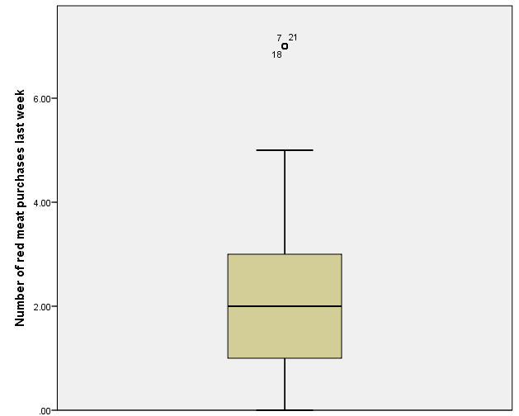 | 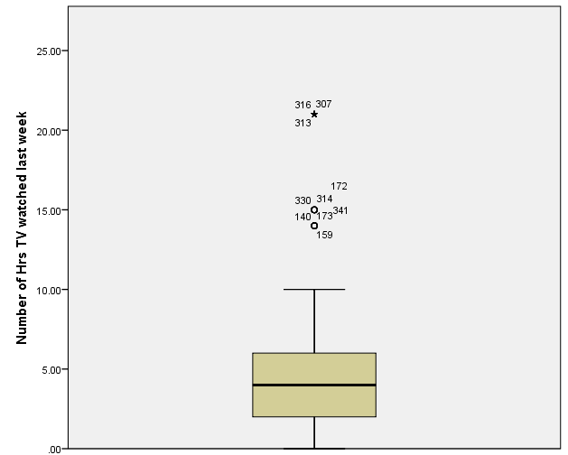
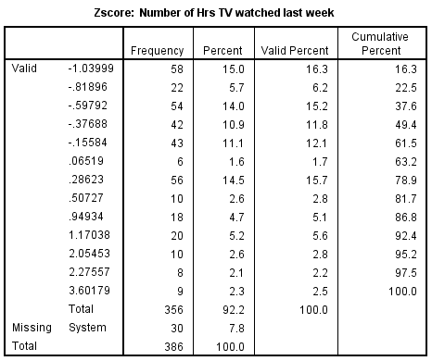 |  | 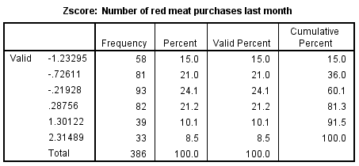

Missing Value Analysis  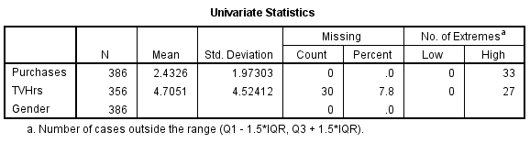 | 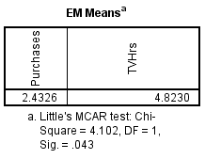 | 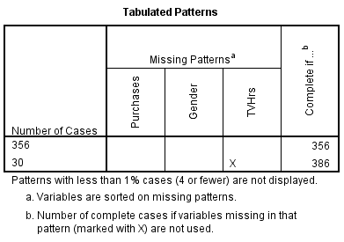
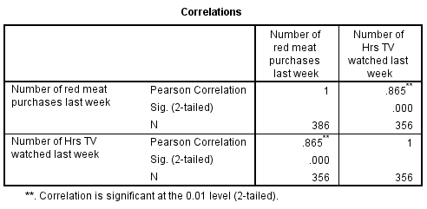 | 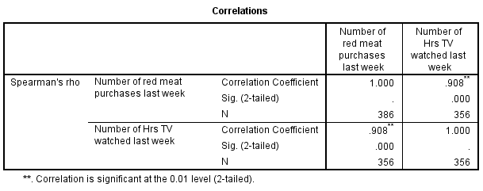

Model for Q2(a) |  | Model for Q2(b)
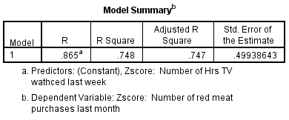 |  | 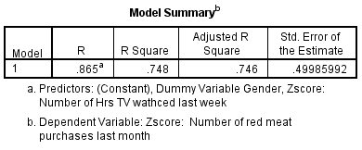
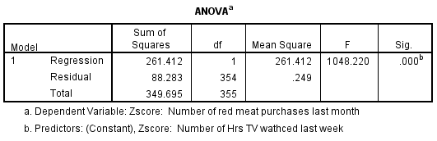 |  | 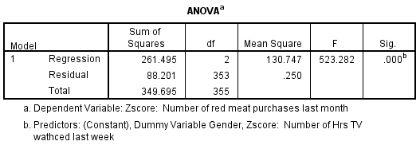
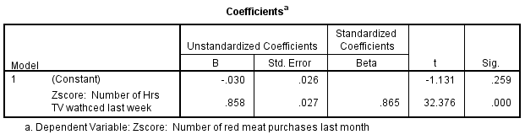
 | 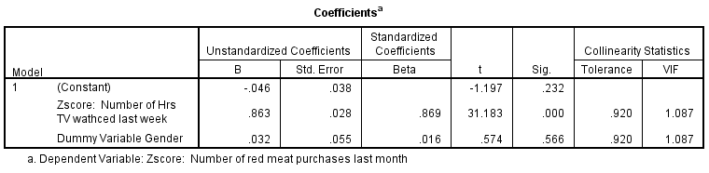
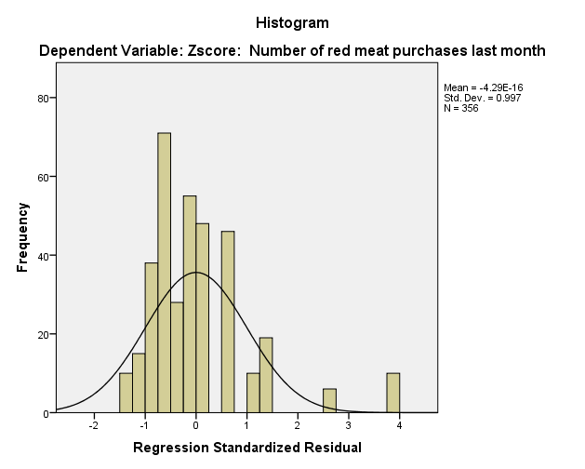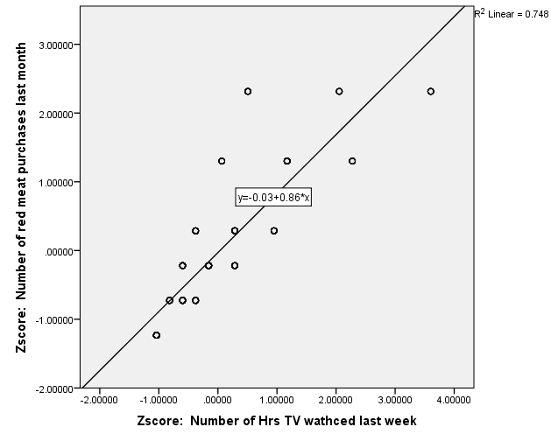 |  |  | 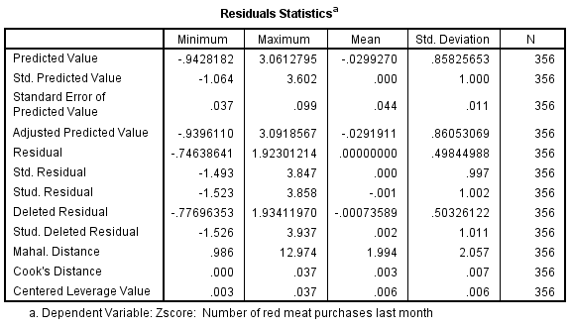
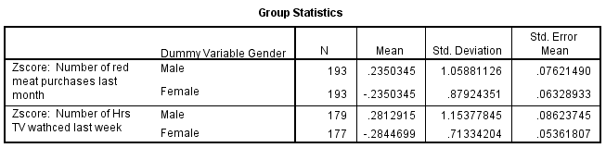

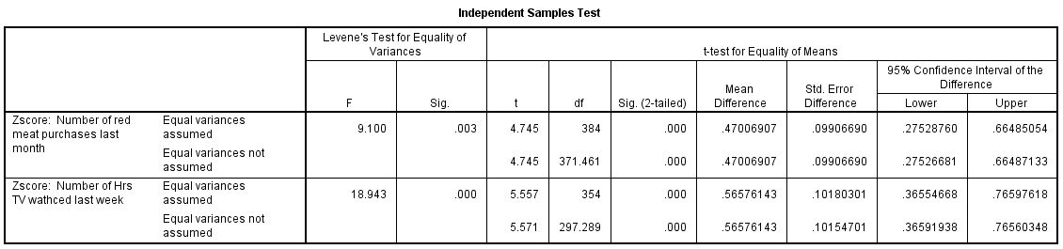

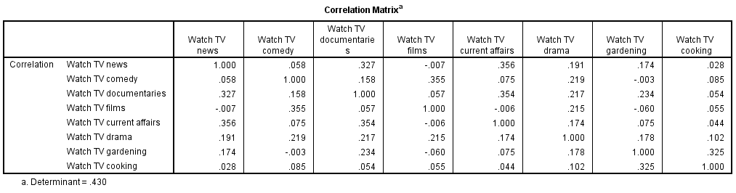 |  | 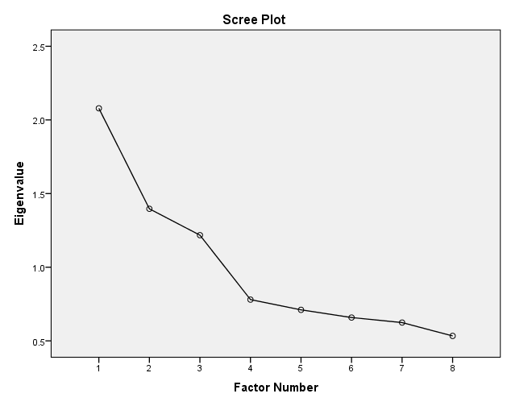
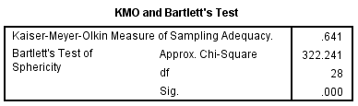  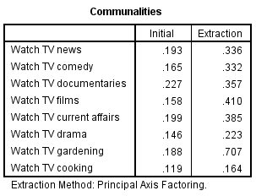 | 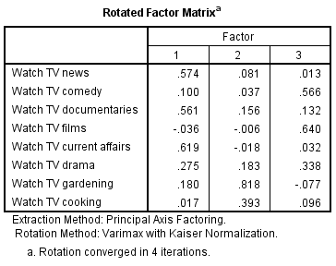 | 